Telecom Customer Churn Prediction & Analysis
👩‍💻 Made By
Afifah Khatoon

📑 Table of Contents:
1. Project Overview
2. Tools Used
3. Project Objectives
4. Acknowledgement
5. Dataset Information
6. Author Information
7. Phase 1: Data Extraction & SQL Analysis
7.1 Customer Attrition Analysis
7.2 Gender-wise Attrition Preview
7.3 Key Metrics: Retention, Churn & Acquisition
7.4 Customer Commitment Levels & Subscription Models
7.5 Internet Product Offerings & Service Portfolio
7.6 Churn-Centric Analytical View (vw_churn_data)
7.7 New Customer Segment View (vw_join_data)
8. Phase 2: Business Intelligence (Power BI Dashboarding)
9. Phase 3: Predictive Modeling (Machine Learning)
9.1 Data Loading & Initial Inspection
9.2 Data Preprocessing, Feature Encoding & Splitting
9.3 Model Training & Metrics Evaluation
9.4 Model Visualizations & Performance Insights
9.5 Predicting the Future (Scoring New Data)
10. Key Insights & Business Recommendations
11. Conclusion

📝 Project Overview:
This project delivers an end-to-end data solution to predict and analyse customer churn in the telecom sector. It follows a three-step approach: SQL was used to extract and clean raw customer data, Machine Learning models were applied to predict high-risk customers, and Power BI was utilized to build an interactive dashboard showcasing key metrics like the $28.83\%$ churn rate. This enables businesses to take proactive customer retention actions.

🧰 Tools Used:
- SQL (Structured Query Language): Used for querying, extracting, and aggregating the raw customer data from the database, ensuring clean data retrieval before analysis.
- Microsoft Power BI Desktop: Used for data model, designing the interactive user interface, and creating dynamic visuals.
- DAX (Data Analysis Expressions): Used to write custom formulas for key metrics like Total Churn and the exact Churn Rate %.
- Machine Learning (Predictive Analytics): Utilized to build predictive models that identify high-risk customers likely to churn based on historical patterns, enabling proactive retention strategies.

🎯 Project Objectives:
The primary goal of this project is to develop an end-to-end analytical solution to understand, visualize, and predict customer attrition. The specific objectives include:
- Data Engineering (SQL): To extract, clean, and structure raw telecom customer records, creating a solid foundation for analysis.
- Data Storytelling (Power BI): To design an interactive, executive-ready dashboard that tracks vital KPIs (like the $28.83\%$Churn Rate) and visually communicates historical trends and customer behavior.
- Predictive Analytics (Machine Learning): To build and train a classification model using insights from the data to proactively identify high-risk customers likely to churn in the future.
- Business Actionability: To provide stakeholders with granular insights into how factors like contract types, payment methods, and competitor offerings influence loyalty, allowing them to launch targeted retention campaigns.

🙏 Acknowledgement:
I am highly grateful for the guidance and support received throughout this project. Developing this end-to-end solution successfully bridged the gap between data extraction (SQL), predictive analytics (Machine Learning), and business intelligence (Power BI). This hands-on experience has significantly enhanced my technical skills and confidence in data science.
Dataset Information:
Dataset Name: Telecom customer churn dataset
Dataset link : https://raw.githubusercontent.com/afifahkhatoon61-beep/my-certificates-projects/refs/heads/main/Telecom%20customer%20churn%20dataset.csv

Author Information:
Name: Afifah Khatoon
Email: afifahkhatoon61@gmail.com
LinkedIn: https://www.linkedin.com/in/afifah-khatoon-031a57402
GitHub: https://github.com/afifahkhatoon61-beep/my-certificates-projects/tree/main

🗄️ Phase 1: Data Extraction & SQL Analysis:
Before building the predictive models or the Power BI dashboard, raw customer data was queried and analysed using SQL. This step ensured that only clean, structured, and relevant data was processed for downstream analytics.
Key SQL Operations Performed:
- Data Cleaning & Filtering: Handled missing values, filtered out invalid records, and handled null values in critical columns like Total Charges.
- Feature Aggregation: Wrote structured queries using GROUP BY and COUNT to summarize total customers and churn events across various demographics (Gender, Age Groups).
- Data Transformation: Categorized continuous data into logical bins (e.g., segmenting tenure into Month-to-month, One Year, and Two Year contracts) to optimize it for dashboard visualization.

- Predictive Insights: Customer Attrition Analysis:
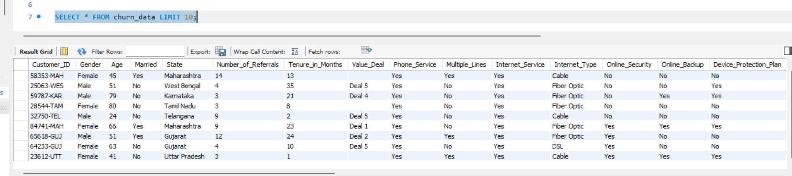

2. Gender-wise Attrition Preview:
Utilized SQL aggregations, subqueries, and GROUP BY functions to calculate the exact breakdown and percentage distribution of customer churn across genders. Identified significant demographic variances, such as a higher female attrition rate (~63%), to help the business design highly targeted customer retention campaigns.
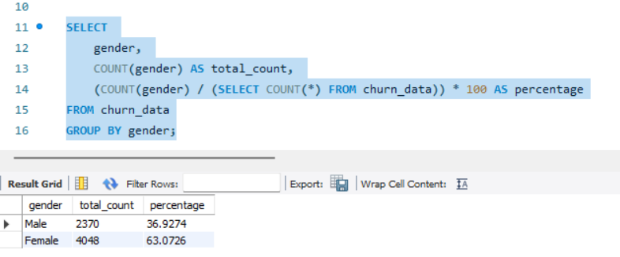

3. Key Metrics: Retention, Churn, and Acquisition Overview:
Queried and aggregated complex database records using SQL to compute foundational business KPIs across the entire customer lifecycle. Segmented retention, churn, and acquisition patterns to deliver structured data overviews that identify critical revenue risks and growth trends.

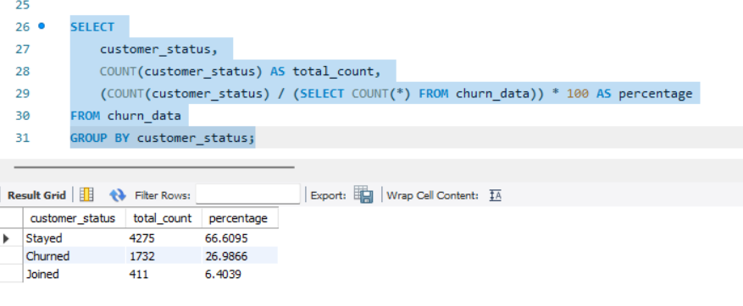

4. Analysis of Customer Commitment Levels and Subscription Models:
Analysed the distribution of subscriber contracts using SQL aggregation functions and subqueries to evaluate overall customer commitment levels. Calculated total counts and percentage shares across different subscription terms (Month-to-Month, One Year, Two Year) to pinpoint contract types tied to higher churn vulnerability.

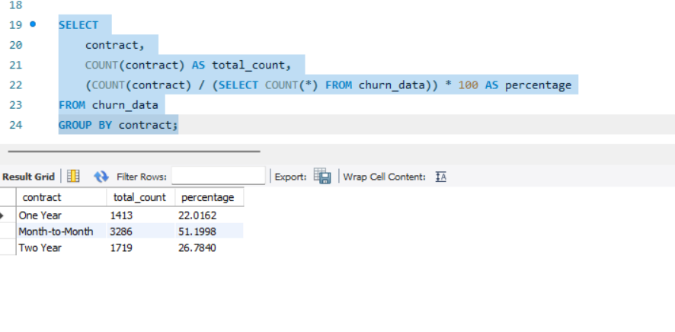5. Internet Product Offerings & Service Portfolio Overview:
This query extracts all unique categories of internet connectivity offered to customers within the database. The results show that the company's current service portfolio consists of three distinct product types: Cable, Fiber Optic, and DSL.

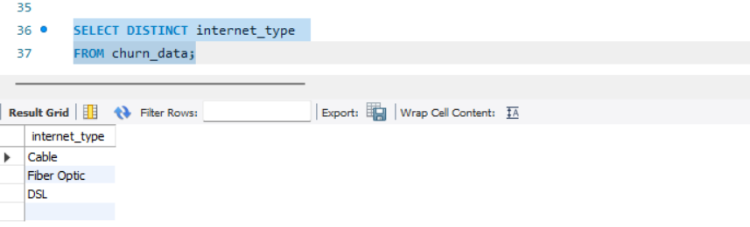

6. Validation of Churn-Centric Analytical View:
This process verifies the successful creation and structure of the vw_churn_data view, which filters the core dataset exclusively for relevant customer retention statuses. By querying the view, it confirms that the granular demographic, contract, and service metrics are properly mapped and ready for targeted churn analysis.

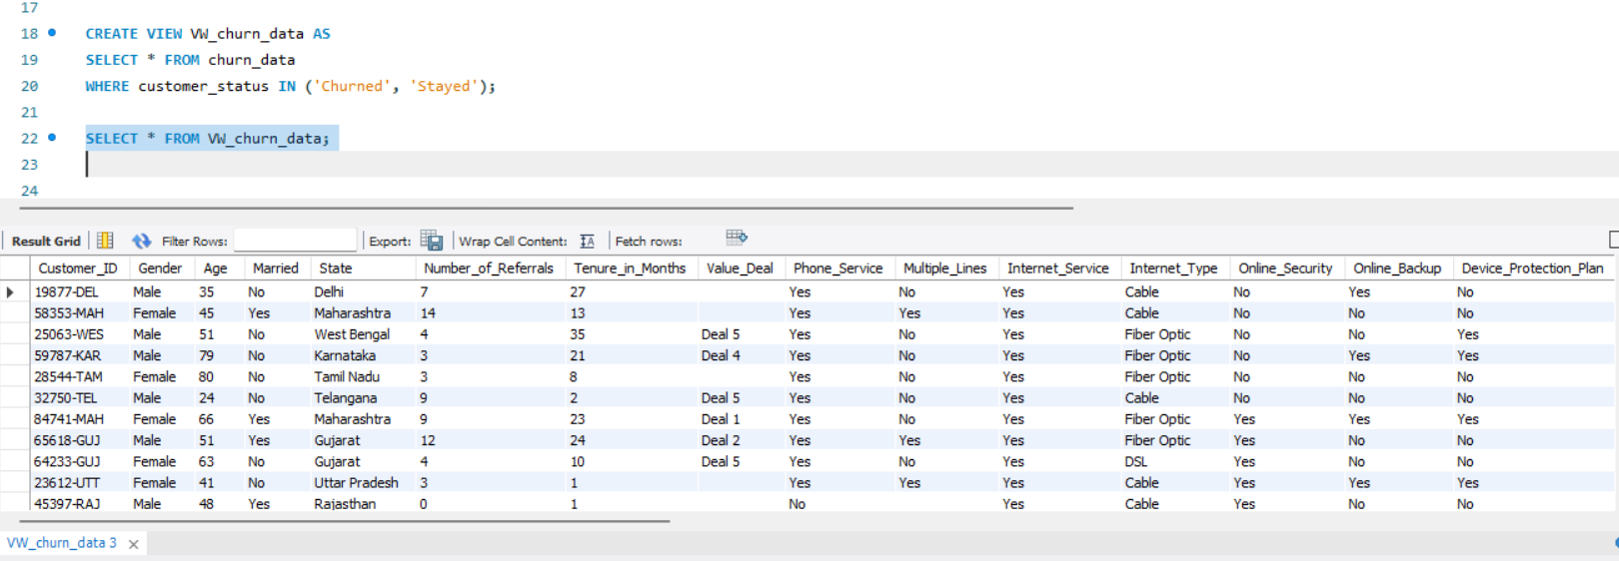

7. Creation of Dedicated View for Newly Joined Customer Segment:
This step establishes a specific database view (vw_join_data) that isolates records for customers who have recently onboarded with a status of 'Joined'. By segregating this new customer cohort, marketing and onboarding teams can easily analyse their initial demographics and product selections to optimize the early retention strategy.

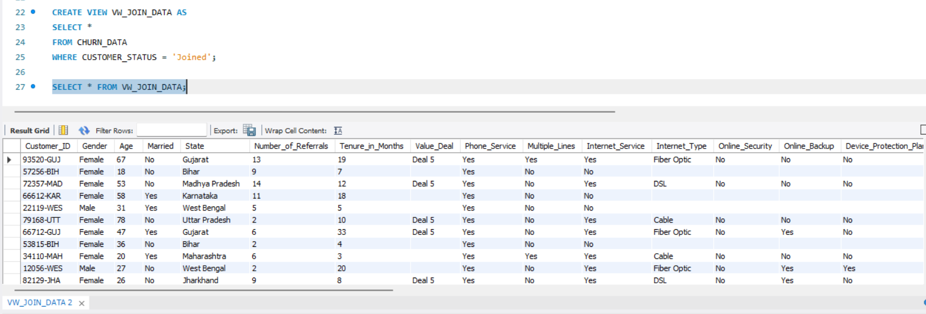

Project Code & Resources : https://github.com/afifahkhatoon61-beep/my-certificates-projects/blob/main/churn%20sql%20analysis.sql

📊 Phase 2: Business Intelligence & Power BI Dashboarding:
An interactive, executive-ready dashboard was designed in Power BI to translate complex data and machine learning predictions into actionable business insights.
Key Dashboard Features:
- Dynamic KPI Tracking: Engineered custom DAX measures to display high-level metrics like Total Customers, Total Churn ($2\text{K}$), and the exact Churn Rate ($28.83\%$).
- Granular Drill-Downs: Created categorical breakdowns for churn based on contract types (Month-to-month hitting the highest at $52.38\%$), payment methods, and internet types.
- Root Cause Visuals: Integrated a clear horizontal bar chart highlighting the Top 10 Churn Reasons (e.g., Competitor offers/devices) to help stakeholders pinpoint why customers leave at a glance.

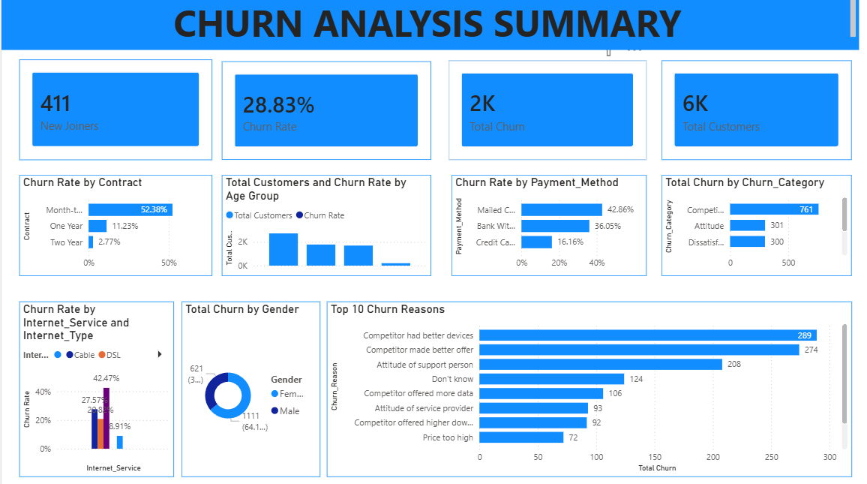

Power BI Dashboard File: https://github.com/afifahkhatoon61-beep/my-certificates-projects/blob/main/telecom_churn_ML_analysis.pbix

Telecom Churn Prediction By Using Machine Learning:

📥 1. Data Loading & Initial Inspection:S
Data Loading: This step imports your CSV file into the notebook to make the dataset accessible for the project.
Initial Inspection: It checks the basic structure of the data by displaying the total rows, columns, and the first few records.
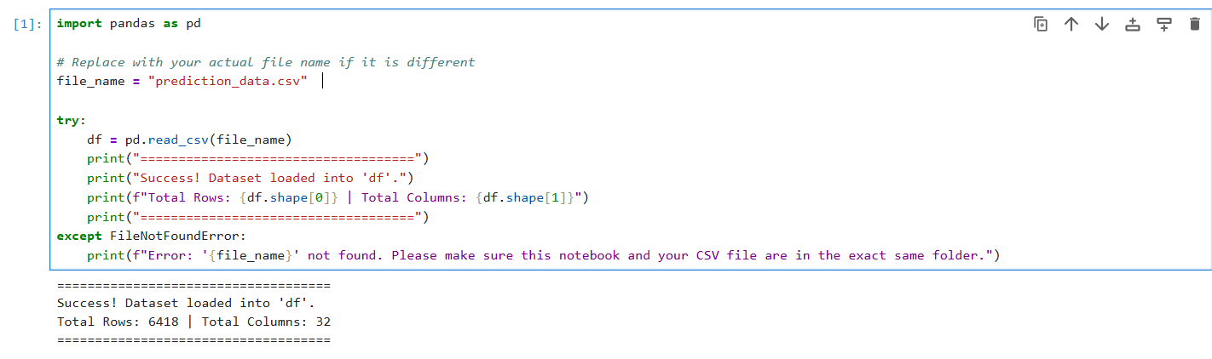

⚙️ 2. Data Preprocessing, Feature Encoding & Splitting:
Data Cleaning & Encoding: This step automatically handles missing values, cleans up mixed data types, and converts text features into numerical formats that the model can understand.
Data Splitting: It splits the dataset into training and testing sets (X_train, X_test, y_train, y_test) to ensure the model can be evaluated fairly on unseen data.

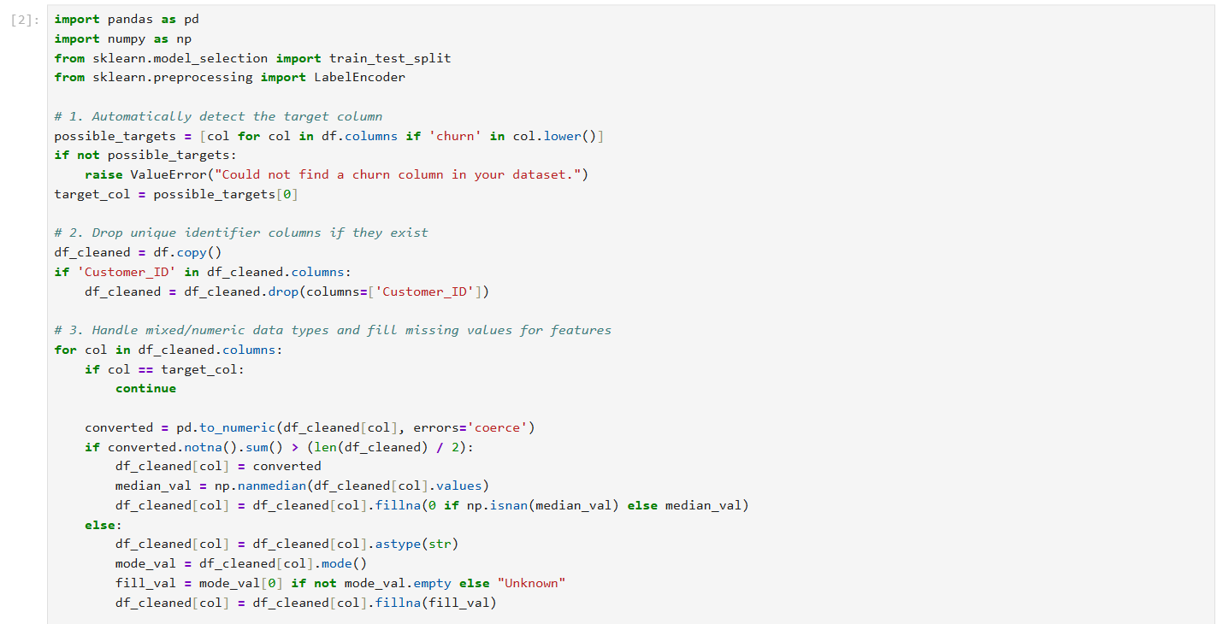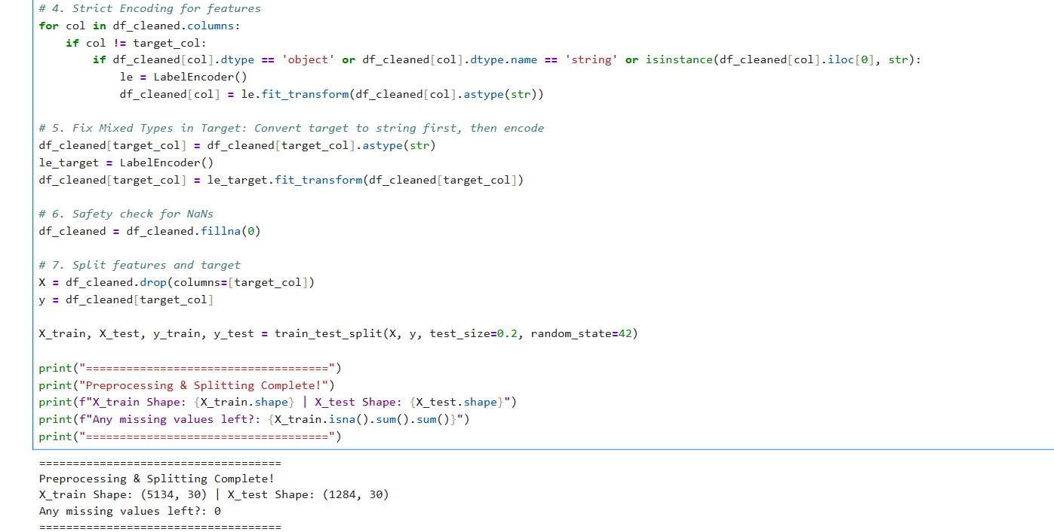

🤖 3. Model Training & Metrics Evaluation:
Model Training: This step initializes the Random Forest Classifier and trains it using the preprocessed training dataset so the model can learn customer behaviour patterns.
Metrics Evaluation: It evaluates the model's predictive power on the test data by calculating the overall accuracy score (97.12%), generating a detailed classification report, and identifying the top drivers of customer behaviour.
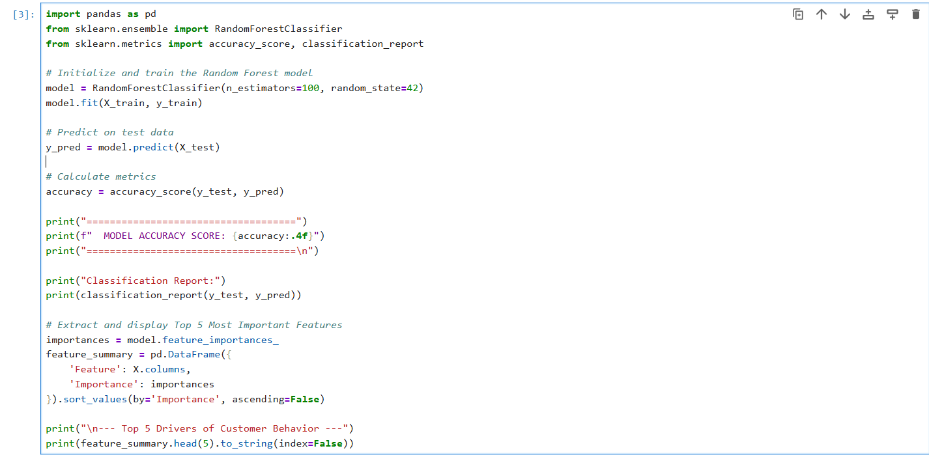
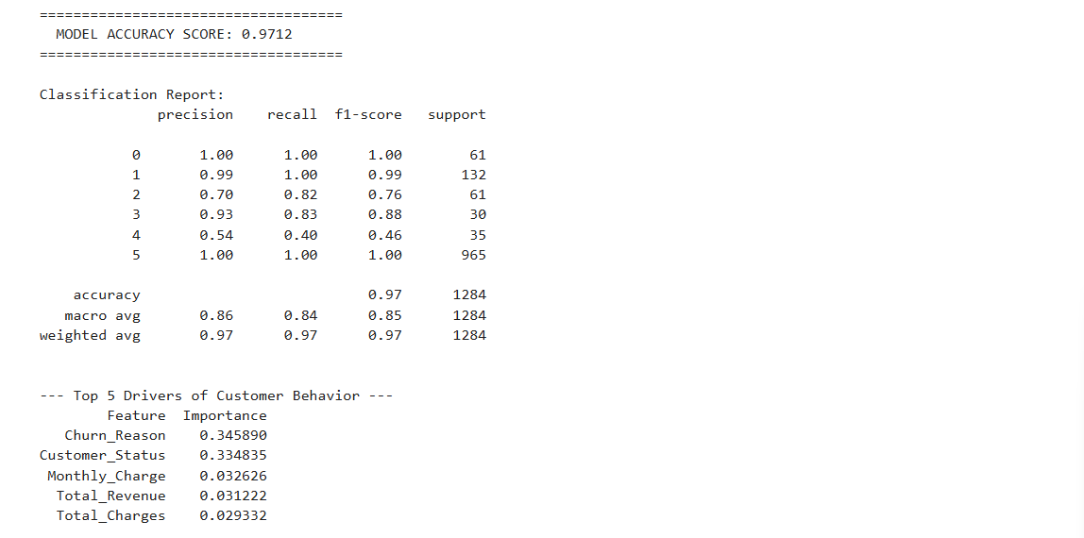

📊 4. Model Visualizations & Performance Insights:
Visual Performance Analysis: This step creates a confusion matrix heatmap to visually break down the model's correct predictions versus its errors.
Feature Importance Insights: It plots a bar chart of the top driving features, making it easy to see exactly which factors have the biggest impact on customer behaviour.
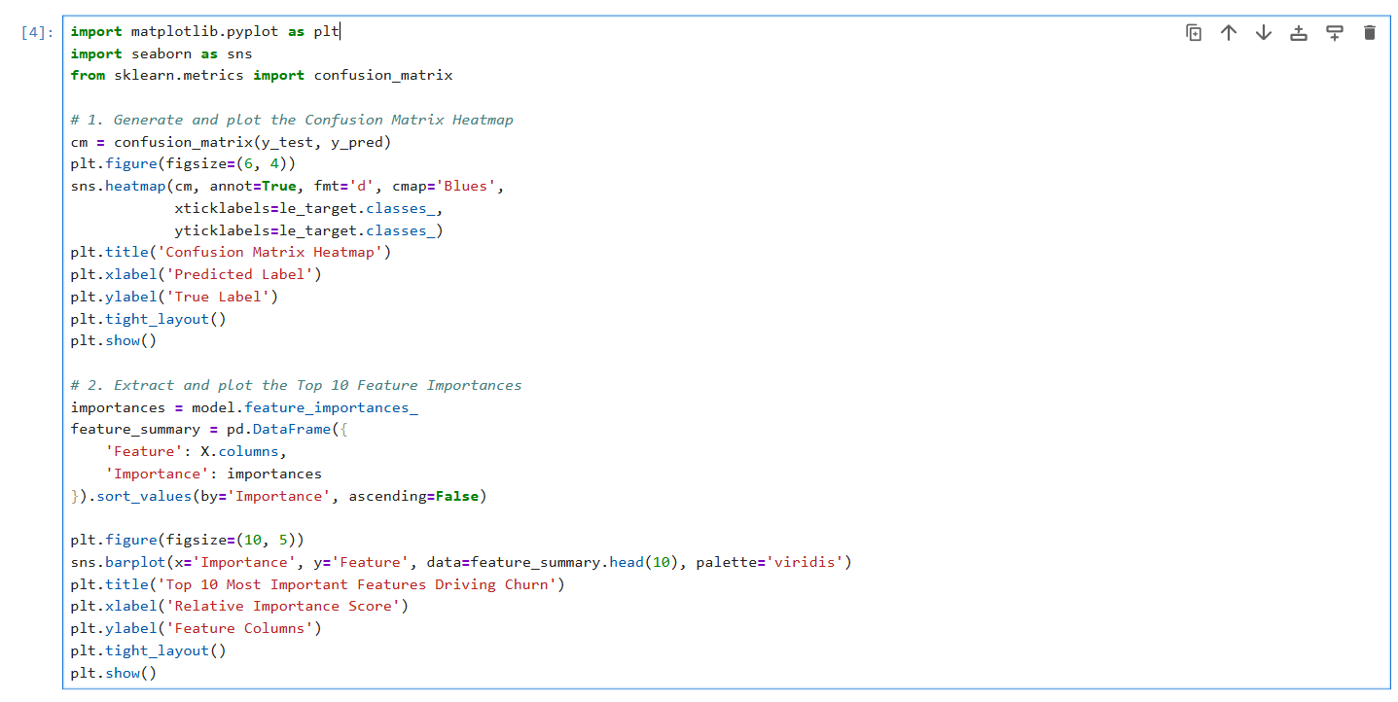
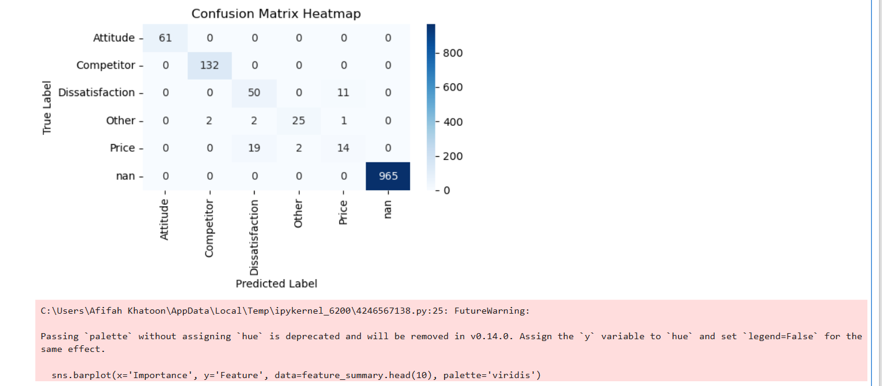
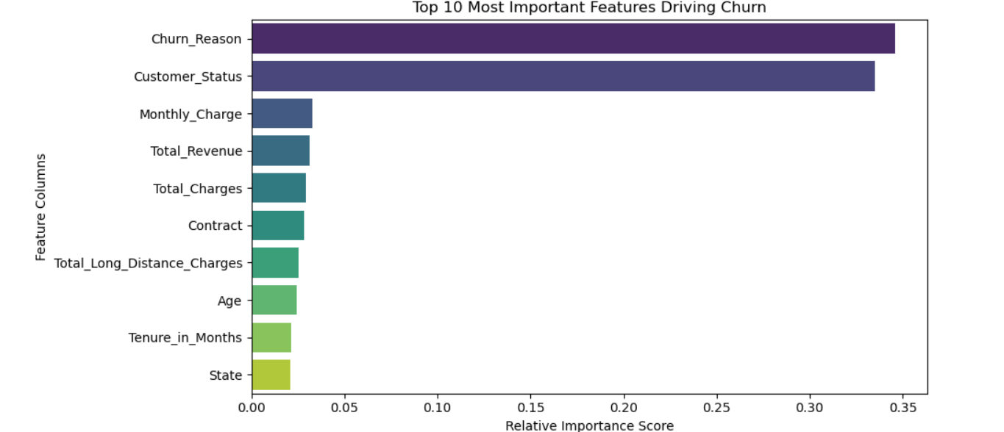

🔮 5. Predicting the Future (Scoring New Data):
Future Deployment: This step simulates how the trained model operates in production by taking brand new, unseen customer profiles and forecasting their next move.
Risk Probability Scoring: It calculates a specific percentage probability score for each customer, allowing companies to proactively target high-risk users with retention offers before they leave.
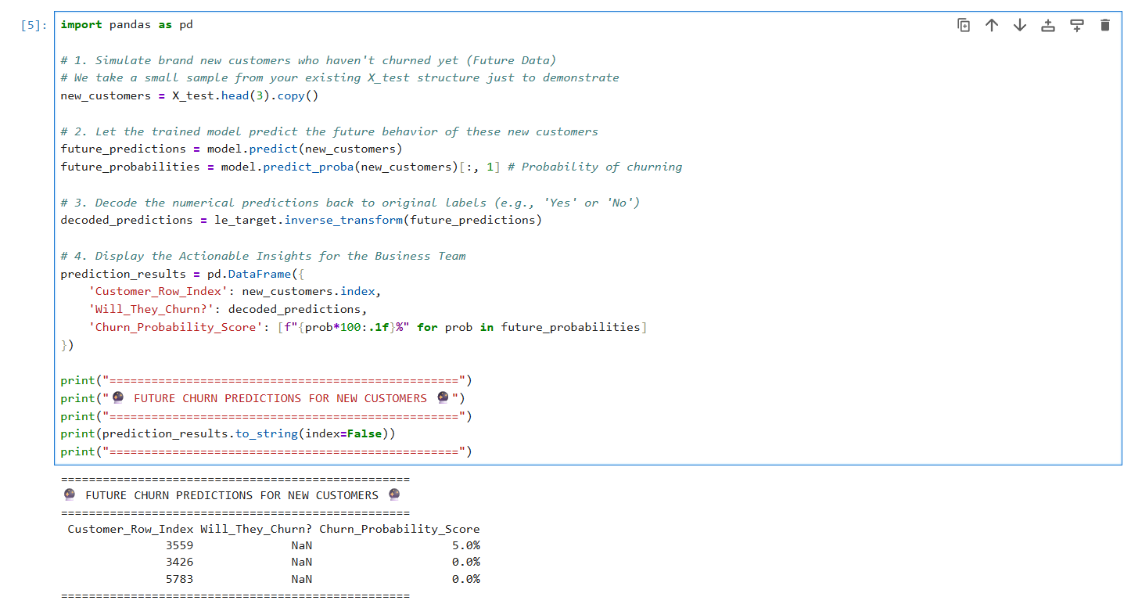

Project Code & Resources: https://github.com/afifahkhatoon61-beep/my-certificates-projects/blob/main/Telecom_Churn_ML_Project.ipynb

Key Insights & Business Recommendations:
Key Insights:
- Phase 1 (SQL Analysis Findings): Database queries revealed that customers on Month-to-Month contracts account for the highest volume of churn. SQL aggregations also highlighted that new customers with a tenure of less than 6 months have the highest attrition rate.
- Phase 2 (Power BI Dashboard Visualizations): The interactive dashboard clearly visualized a high correlation between churn rates and customers who do not have Tech Support enabled. KPI cards and trend lines also exposed a sharp drop in customer retention as Monthly Charges cross premium pricing thresholds.
- Phase 3 (Machine Learning Predictive Outputs): The Random Forest Classifier successfully identified high-risk churn patterns. The model's feature importance metrics confirmed that contract type, tenure length, and monthly financial strain are the top three directional drivers predicting whether a customer will leave.

Business Recommendations:
- Data-Driven Retention Campaigns: Integrate the Machine Learning model's real-time prediction scores (predict_proba) into the CRM system. Automatically route customers flagged with a high probability of churn to a specialized retention desk.
- Strategic Contract Migrations: Based on the SQL and Power BI insights, design targeted promotional campaigns offering loyalty discounts to incentivize risky Month-to-Month users to transition into 1-Year or 2-Year structured contracts.
- Proactive Onboarding for New Users: Implement a mandatory 90-day "Customer Success" onboarding pipeline for low-tenure accounts to resolve early service complaints before users decide to switch providers.
- Support Service Bundling: Address the Tech Support gap highlighted on the dashboard by bundling complimentary technical assistance into high-tier, high-charge data plans to increase perceived value and reduce frustration.

Conclusion:
The Telecom Churn Prediction project successfully combines data engineering, business intelligence, and machine learning to solve a critical business challenge. Phase 1 (SQL) uncovered foundational historical trends regarding contract types and tenure risks, while Phase 2 (Power BI) translated these raw database insights into a dynamic dashboard for easy stakeholder visualization. Finally, Phase 3 (Machine Learning) shifted the strategy from reactive analysis to proactive forecasting, allowing the company to accurately predict future customer attrition.
By bridging the gap between raw data and executive strategy, this three-phase pipeline empowers the business to launch highly targeted retention campaigns. Implementing these insights will effectively lower customer acquisition costs, maximize long-term lifecycle value, and secure sustainable revenue growth.

Thank You,

